**Fixsel – experiences in digital materiality**

**Matt Ratto**

**ginger coons**

**Faculty of Information**

**University of Toronto**

**w/Isaac Record, Antonio Gamba-Bari, and Dan Southwick (ground control)**

Digital technologies no longer run parallel to the "real world", but have instead been seamlessly woven into the fabric of everyday life, acting at an affective and infrastructural level to articulate contemporary experience. (e.g. Lash, 2002; Thrift, 2005) In 1984, William Gibson could describe cyberspace as "a consensual hallucination" and as "lines of light ranged in the nonspace of the mind." (Gibson, 1984, 69) But for us, now, Cyberspace is no longer a separate locale or 'nonspace', accessed by peering intently into a screen in a closed protected room, far from the vagaries of the physical world. Instead, most of us live our lives in a hybrid space of digital and physical interactions with little distance between the two.

However, the law and other formal and informal entities are used to treating 'the digital' and 'the physical' as two entirely separate worlds. We have been encouraged to think this way by a whole variety of individuals and institutions, including both libertarian (e.g. John Perry Barlow's famous 'Declaration of the Independence of Cyberspace') and conservative voices (e.g. reasoning regarding the DMCA in the US,) depending on need. Over the last few decades, much labor has been spent to encourage the idea that information is immaterial, that form and content can be separated, that the medium is just a neutral channel for transmission.

The digital humanities was quick to pounce on the fallacy of the immateriality of information, with scholars such as Katherine Hayles, Joanna Drucker, and Paul Dourish pointing out the political and social issues engendered by such a belief. Drawing upon feminist scholarship including the work of Donna Haraway, Hayles highlighted the ways arguments about the immateriality of information worked to efface the embodied nature of human experience. Similarly, Drucker has described the ascension of ‘mathesis’ Somewhat more recently, Matthew Kirshenbaum has noted that "computers are unique in the history of writing technologies in that they present a pre-meditated material environment built and engineered to propagate an illusion of immateriality".

But simply acknowledging the ‘materiality’ of the digital is not enough. What constitutes this materiality? Why and in which ways does the digital ‘matter’? Do the ever increasing number of puns on ‘matter’ and the digital expand our understanding or as Barad has noted, (Barad, 2003) do such figures of speech in fact prefigure the nonfigurative aspects of the digital in ways that simple relieve our conceptual anxieties without resolving them?

Let’s try an alternative tack – using material practice to supplement critical reflection – critical making!

Physical Pixel

Goal: think through screens and environments and porosity of digital information and space. What happens when digital information moves off/out of screens and into our spaces and environments? When we no longer (only) engage with digital information through ‘windows’ into a digital world? What is ‘digital materiality’? What is the role of the digital humanities in sorting it out?

Tech: ATTiny powered RGB LED inside origami 'water balloon'

colour of led set using conductive traces on outside

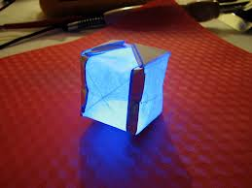

Build Process:

1. Build circuit with copper tape

2. Glue support squares

3. Fold paper into origami balloon.

4. Unfold

5. Superglue ATTiny and RGB LED in place

6. Attach leads from components to traces

7. Let dry (15 min) – FIKA!!!

8. Refold paper into origami balloon.

9. Install battery (use paperclip)

Process of use:

hold pixel near screen image

Hold traces to run through colours (RGB colour wheel)  until find one that matches pixel on screen.

move pixel to alternative place and attach with sticky tape.

Parts:

Attiny 85

Flora Neopixel rgb led

cr2032

double-sided tape

bare paint (tubes)

paper square (printed traces)

copper tape

card stock

Drucker, Speclab

Kirschenbaum, Mechanisms

Introductions (Matt and ginger)

conceptual overview of workshop (matt)

what we will do (Matt)

pragmatics - organize into groups, make sure all have parts/tools (ginger and Umea crew)

Walk through of build - show build photos and maybe video (matt and ginger)

Questions?

Overview of digital materiality - slides, quotes from Drucker and Kirschenbaum (Matt)

Show photo (Invention of drawing) and subset of for reproduction - project appropriately (stable screen somewhere - maybe floor?)

Build - ginger folds and talks? (ginger)

When reach drying of conductive paint take 10 -15 min break

Complete build

Choose wall to attach fixsels

Install

Troubleshoot

Discussion (Matt and ginger)

Quotes for circuit template:

Not only are no two pixels alike, but the material expression of any algorithm varies from screen to screen, from moment to moment, from viewer to viewer. Embodied materiality is always distinct from the code it expresses. (Drucker, Speclab, 139)

The existence of the image depends on the display, the coming into matter in the form of pixels on a screen. If, in one instance, the graphic display is manipulated by an algorithm, then, in other instances, the display becomes the site for manipulation of the algorithm. After all, the image on the screen is not even identical to itself. (Drucker, Speclab, 139)

In brief, forensic materiality rests upon the principle of individualization (basic to modern forensic science and criminalistics,) the idea that no two things in the physical world are ever exactly alike… (Kirschenbaum, Mechanisms, 10)

Formal materiality thus follows as the name I give to the imposition of multiple relational computational states on a data set or digital object. Phenomenologically, the relationship between these states tends to manifest itself in terms of layers or other relative measures, though in fact each state is arbitrary and self-consistent/self-contained. (Kirschenbaum, Mechanisms, 10)

For slides – each slide contains one quote

Drucker: “Embodied materiality is always distinct from the code it expresses”

The idea of digitality as transposing ‘pure’ idea into ‘pure’ form:

…the digital image is (popularly and fundamentally) conceived as another kind of truth, premised on a deep conviction about a rational link between mathematics and form that is supposed to be irrefutably present in digital code. This premise is the foundation of a digital ontology. It promotes the idea that mathematical code is self-identical, irrespective of its material embodiment. This is a potent myth. (137)

But Drucker reveals the fallacy of this idea:

The existence of the image depends on the display, the coming into matter in the form of pixels on a screen. If, in one instance, the graphic display is manipulated by an algorithm, then, in other instances, the display becomes the site for manipulation of the algorithm. After all, the image on the screen is not even identical to itself.

Not only are no two pixels alike, but the material expression of any algorithm varies from screen to screen, from moment to moment, from viewer to viewer. Embodied materiality is always distinct from the code it expresses. Conditions of use and perception enter into the production of an image in a very real sense, since forms are neither immaterial nor transcendent. (139)

Alternative starting place:

Whatever the “ideality” of code may be, even if it were available to sentience in some unmediated way, the encounter of expression and matter produces thought as form. Any interpretive act returns to this initial *inscription through its own productive and generative process*, reinscribing a work as product within a specific situation of viewing. (140)

When working with software, we establish and dissolve formal materialities routinely as digital objects more between different information states. We see this as an object is transformed through a succession of different formats, each one imposing a different computational structure than its predecessor. (Kirschenbaum, Mechanisms, 142)

In brief, forensic materiality rests upon the principle of individualization (basic to modern forensic science and criminalistics,) the idea that no two things in the physical world are ever exactly alike… (Kirschenbaum, Mechanisms, 10)

Formal materiality is perhaps the more difficult term, as its self-contradictory appellation might suggest. “Instead of manipulating matter, the computer allows us to manipulate symbols” (Negreponte) (Kirschenbaum, Mechanisms, 11)

Formal materiality thus follows as the name I give to the imposition of multiple relational computational states on a data set or digital object. Phenomenologically, the relationship between these states tends to manifest itself in terms of layers or other relative measures, though in fact each state is arbitrary and self-consistent/self-contained. (Kirschenbaum, Mechanisms, 12)

A simple example is a digital image file. An image file is typically considered to consist of nothing but information about the image itself – the composition of its pixelated bitmap, essentially. (Kirschenbaum, Mechanisms, 12)

However, the image can carry metadata (documentation as to how it was created, embedded as plain text in the file’s header,) as well as more colorful freight, such as a steganographic image or digital watermark. This content will only become visible when the data object is subjected to the appropriate formal processes which is to say when the appropriate software environment is evoked…( (Kirschenbaum, Mechanisms, 13)

“…tries to capture something of the procedural friction or perceived difference – the torque – as a user shifts from one set of software logics to another… a relative or just-in-time dimension of materiality… ((Kirschenbaum, Mechanisms, 13)

Images to choose from:

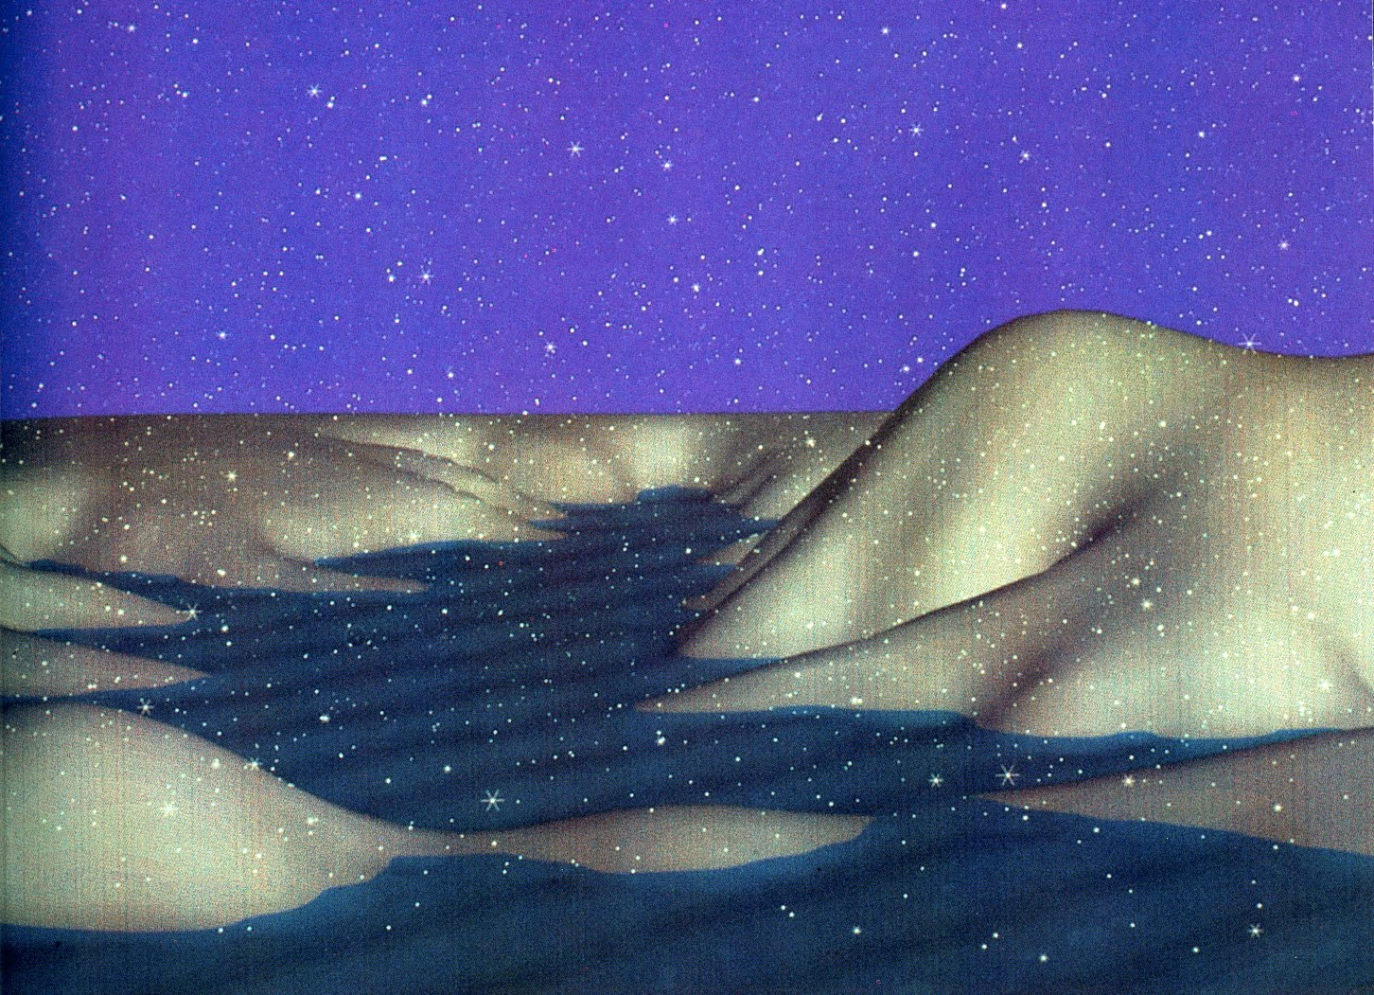

Arctic Twilight (Melvin L. Prueitt, Art and the Computer, 1984)

Perhaps the most compelling, chilling image that I have come across in thinking about these issues is a computer-generated graphic by a very early experimenter in this field, artist-scientist Melvin Prueitt. It is a nocturnal image of a field of snow, unbroken and undisturbed. To my mind this is a terrifying image of the ideal of digital purity, the pristine visual manifestation of code. Nothing human or circumstantial disturbs its form. But it certainly is not pure, any more than any other image out- put by a plotting pen, laser jet, or Giclée printer. (Drucker, 139-140)

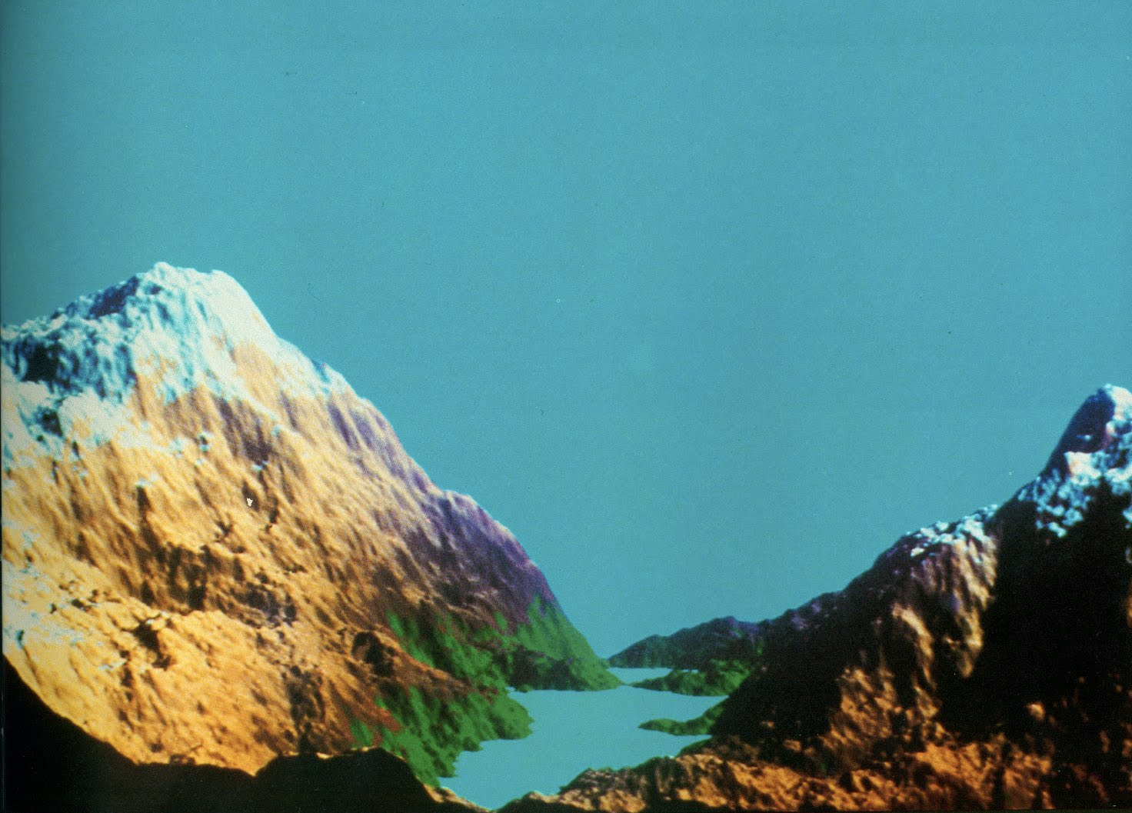

Richard F. Voss used fractal geometry to produce a very realistic scene. (1982 Benoit B. Mandelbrot, IBM Thomas J. Watson Research Center) (Melvin L. Prueitt, Art and the Computer, 1984)

Images from Schinkel’s Invention of Drawing (referenced in Drucker, Speclab)

